
SCHOOL: of Computing and Informatics

Department: Department of Information Technology

Submitted by: HAFIDH RAMADHAN BENDERA

Registration Number: BSCCS/2024/55412

Unit Title: ADVANCED WEB DESIGN

Institution: Mount Kenya University

Lecturer: Mr. Micheal Nyoro

Contents
LOCALHOST TESTING 3
DATABASE CONNECTIVITY TESTING. 4
HELLO WORLD PAGES CREATION. 4
Login page (UI STRUCTURE) 5
HOMEPAGE PRODUCT LAYOUT. 5
DASHBOARD (ADMIN INTERFACE) 6
TECHNOLOGIES SELECTED. 6
JS FORM VALIDATION. 7
DOM MANIPULATION & USER INTERACTION. 7
FORM VALIDATION (FAILURE) 9
FORM VALIDATION (SUCCESS) 9
PHP processing 9
FOLDER STRUCTURE 10
CODE SNIPPETS 10
GITHUB UPDATES 11
USERS TABLE ( PHPMYADMIN) 12
CRUD OPERATION. 12
LOGIN DATABASE INTERGRATION. 13
GITHUB UPDATES. 13

WEEK 1.
INSTALLATION OF XAMMP
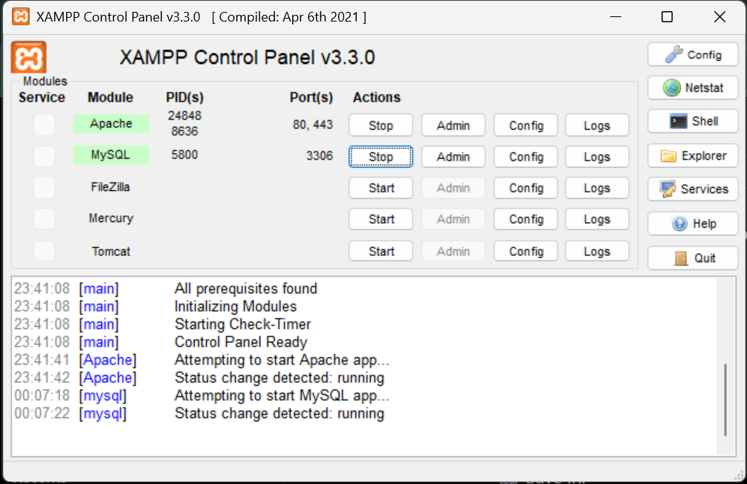
LOCALHOST TESTING
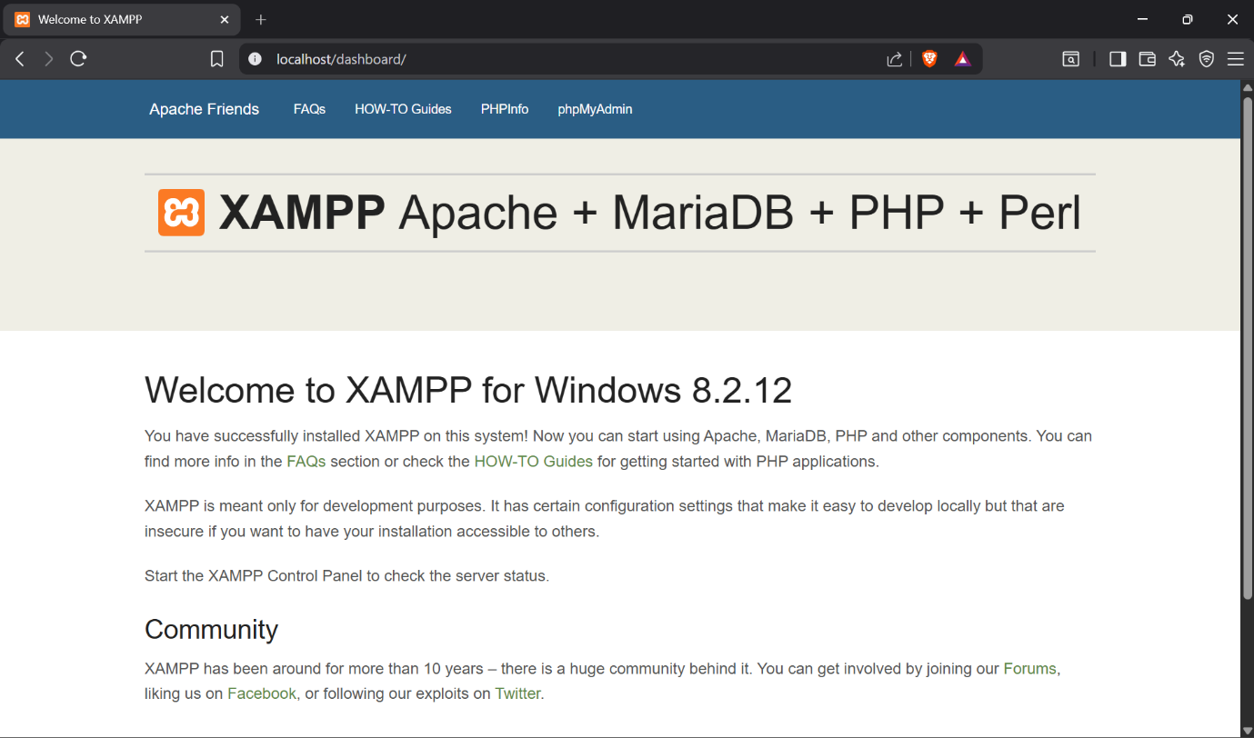
DATABASE CONNECTIVITY TESTING.
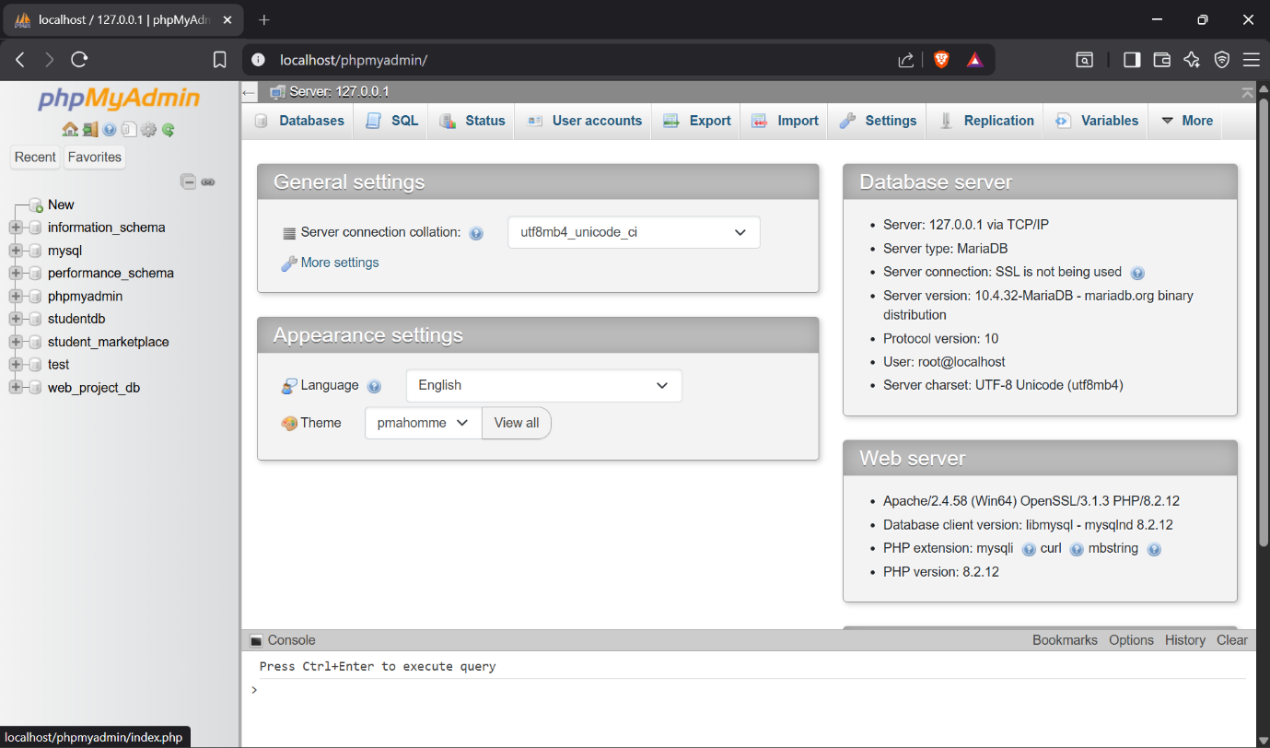

HELLO WORLD PAGES CREATION.
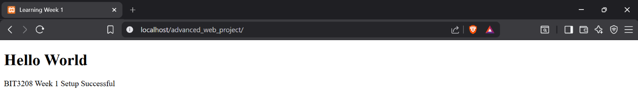

WEEK 2.
DESIGNED WIREFRAMES (FIGMA).
Login page (UI STRUCTURE)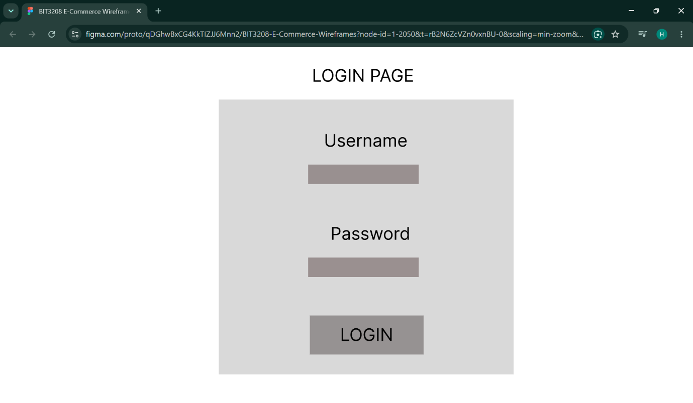

HOMEPAGE PRODUCT LAYOUT.
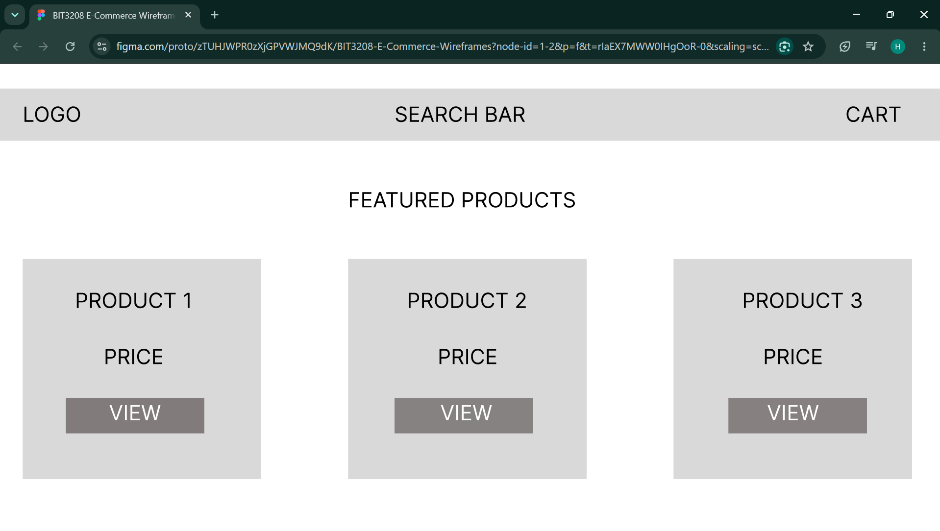

DASHBOARD (ADMIN INTERFACE)
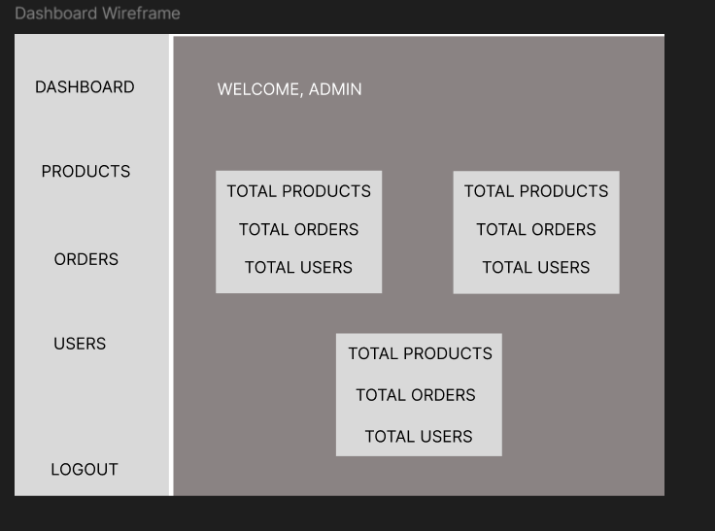

TECHNOLOGIES SELECTED.
HTML, JS, PHP, MySQL.

WEEK 3.

JS FORM VALIDATION.
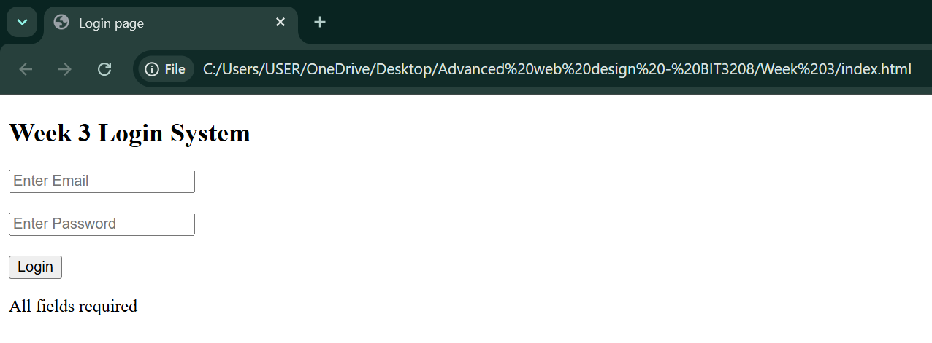

DOM MANIPULATION & USER INTERACTION.
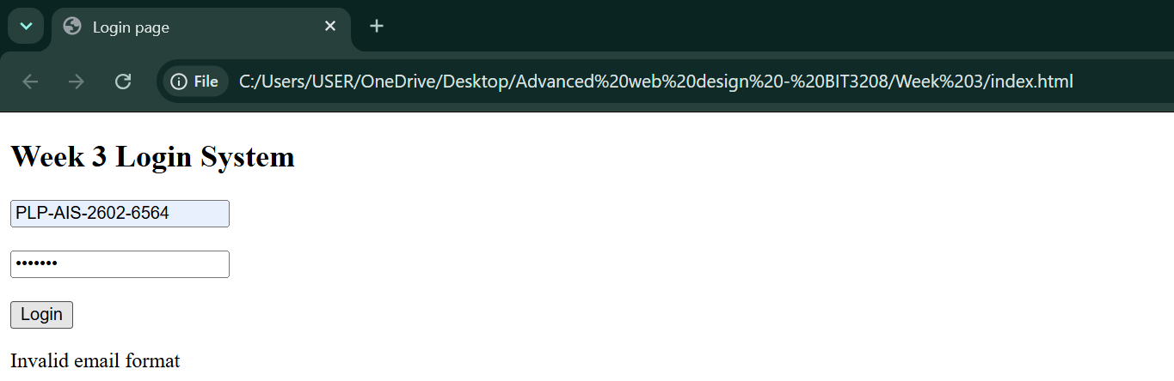
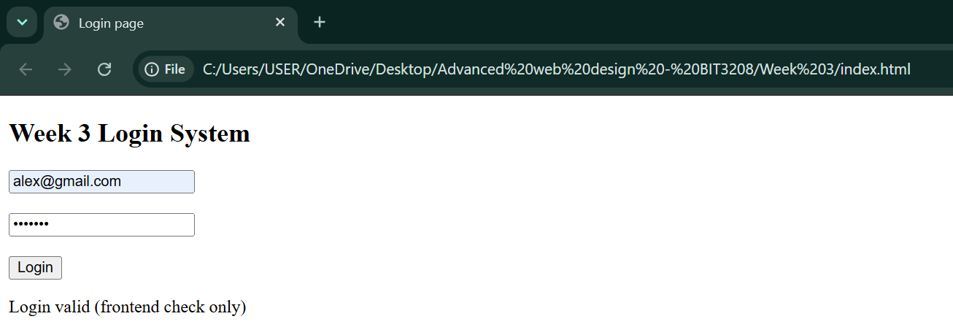
PHP FORM PROCESSING SCRIPTS
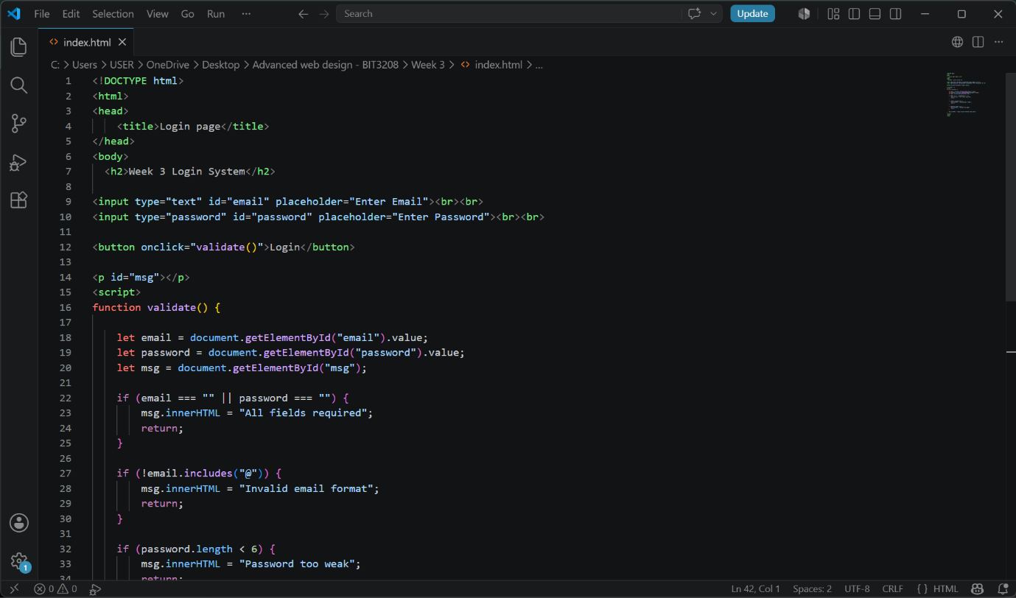
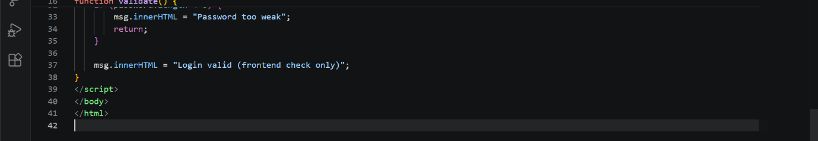
SERVER-SIDE INPUT VALIDATION.
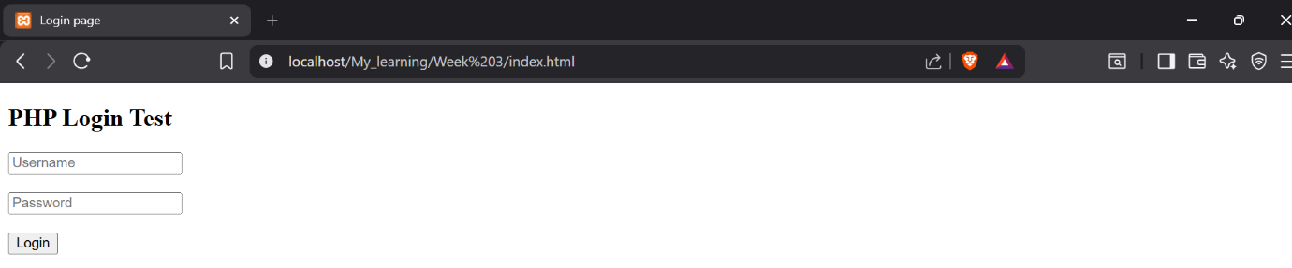
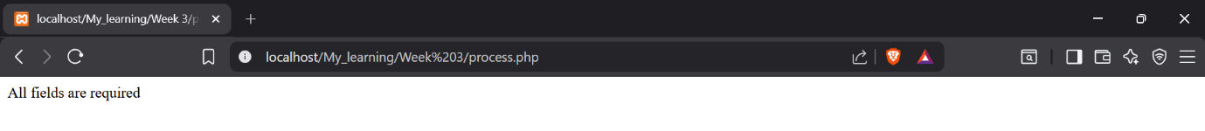

WEEK FOUR.
LOGIN FORM
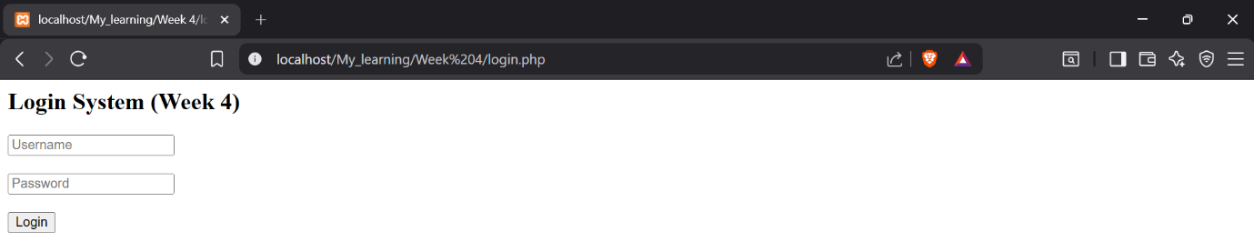

FORM VALIDATION (FAILURE)
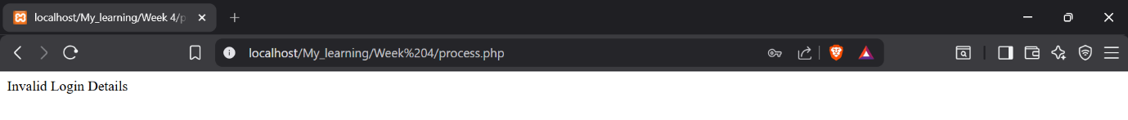

FORM VALIDATION (SUCCESS)

PHP processing
FOLDER STRUCTURE
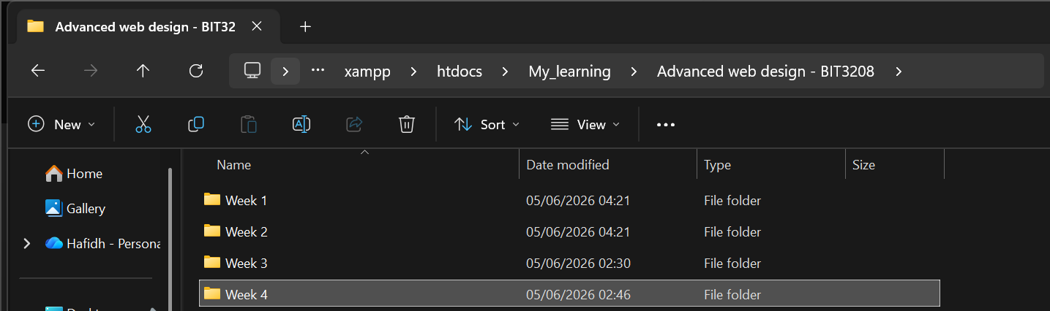

CODE SNIPPETS
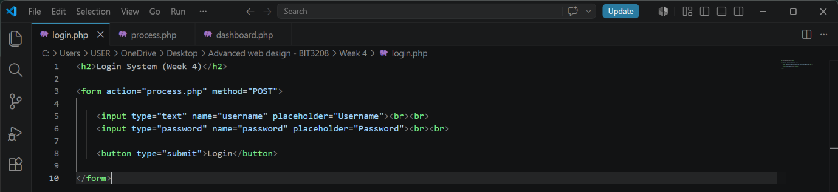

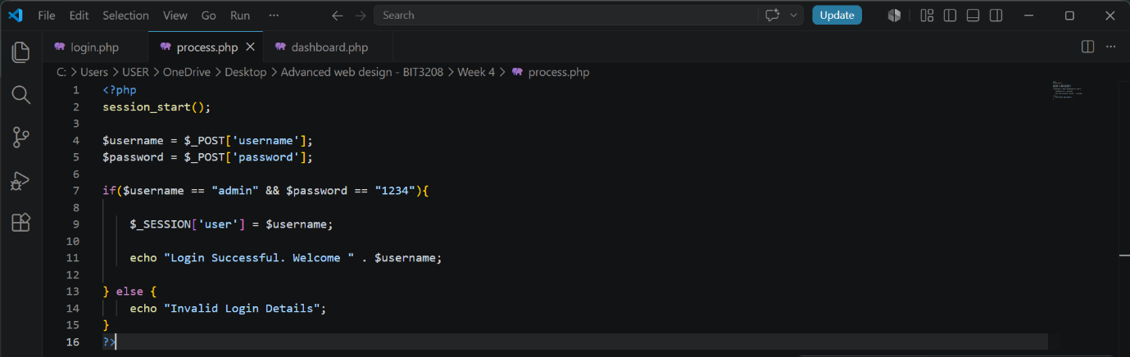
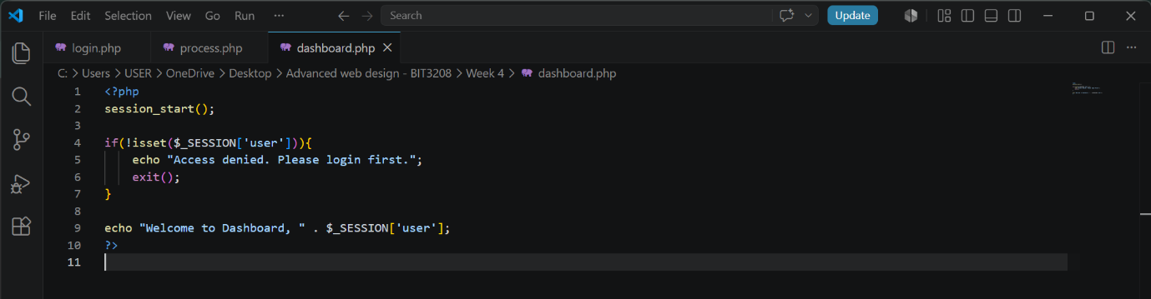
GITHUB UPDATES
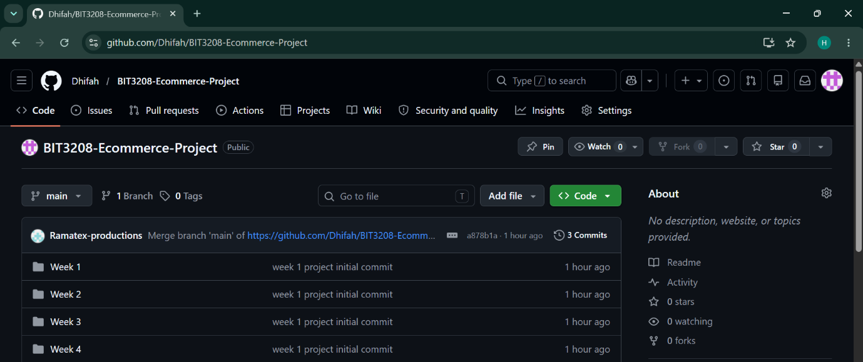
WEEK 5.
DATABASE
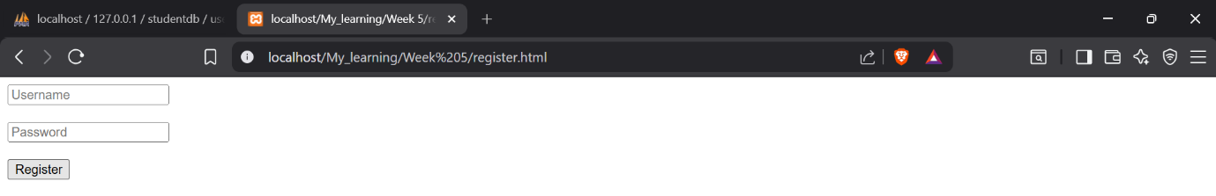

USERS TABLE ( PHPMYADMIN)
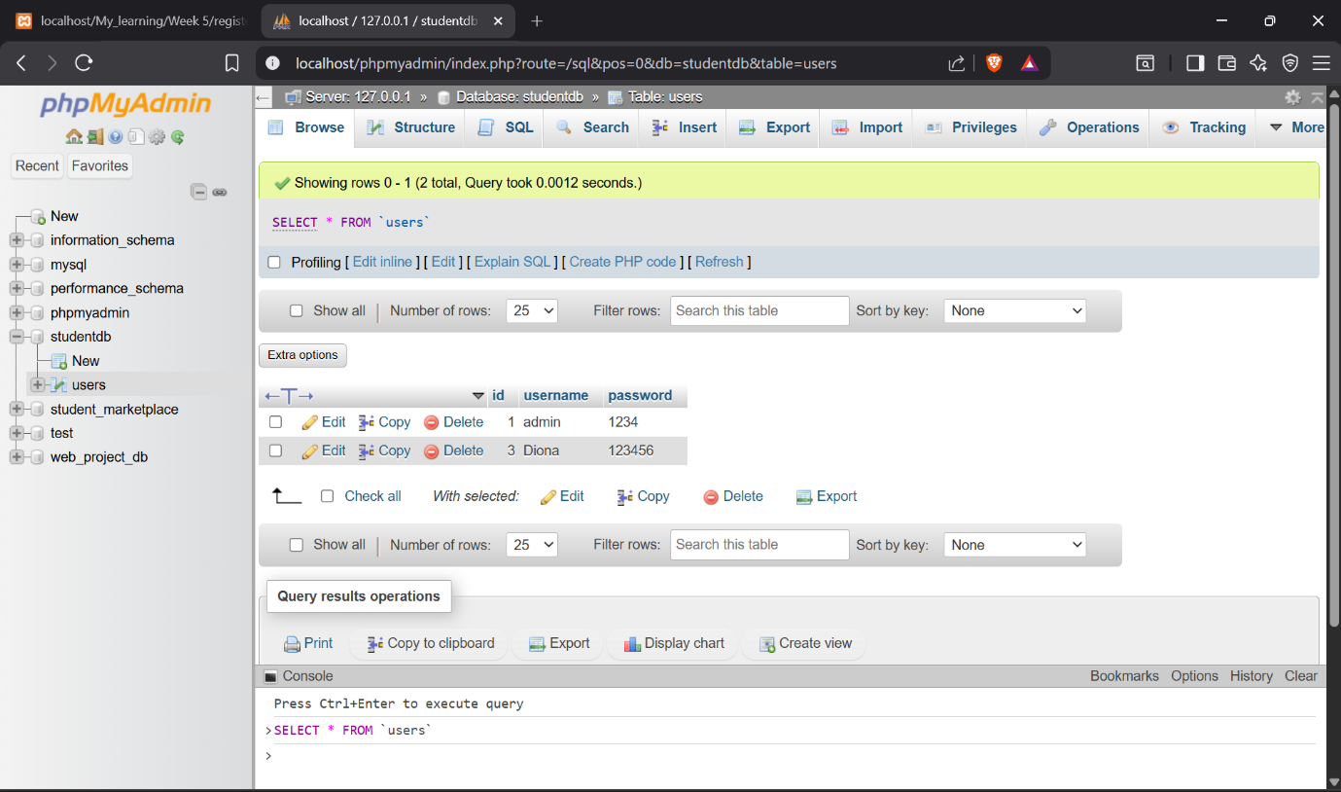

CRUD OPERATION.
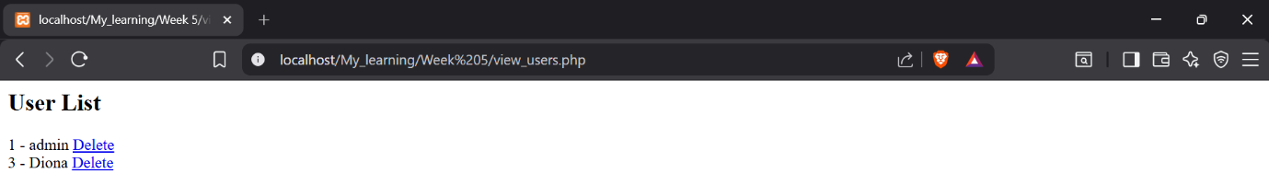

LOGIN DATABASE INTERGRATION.
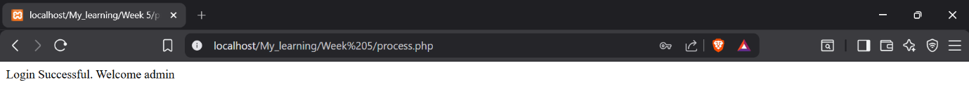

GITHUB UPDATES.
